**Grade 11 Computer Science ISP**

Overall expectations being assessed in this independent study project:

• A1. demonstrate the ability to use different data types, including one-dimensional arrays, in computer programs;

• A2. demonstrate the ability to use control structures and simple algorithms in computer programs;

• A3. demonstrate the ability to use subprograms within computer programs;

• A4. use proper code maintenance techniques when creating computer programs.

• B1. use a variety of problem-solving strategies to solve different types of problems independently…;

• B2. design software solutions to meet a variety of challenges;

• B4. apply a software development life-cycle model to a software development project;

**Scope**

Aim to create a modest application that solves a problem you care about. If you solve the problem well, it is highly likely that others will find your application useful as well. Challenge yourself with something new, but avoid overreaching.

**Due dates**

The proposal is due on Tuesday, February 28, 2017, at the start of class.

The first checkpoint (prototype) is due on Wednesday, March 8, 2017.

The second checkpoint (second prototype) is due on Tuesday, April 4, 2017.

The final submission (completed product) is due on Monday, April 10, 2017.

Note that you will be granted significant opportunities to work in class, but that there is, like any Grade 11 university preparation course, an expectation that work be completed outside of class time as well.

**Proposal**

Modify this document and add your responses to the following prompts below.

**What problem will your application solve?**

*Write a paragraph to describe the utility of your application. This applies equally for games. When would someone use your application? Why would they use your application?*

The proposed application will solve the common problem for RSGC students and parents of forgetting one’s daily class schedule. The application will allow students to enter their schedule and see what classes they have on any given day as well as check their schedule on any future date to assist them with booking appointments or verifying which classes they will miss due to extracurricular activities.

Provided read-only access to the school’s database is available to the undersigned, students will also be able to login using their RSGC Firstclass credentials. With read-only database access, it would also be possible for the students to view their grades for each class as it appears in their schedule. If read-only access is not feasible, an alternate solution will be to provide a feature whereby students and parents create an account associated with the desired school schedule. Parents with more that one son attending the school will also be able to add multiple students and schedules to their account. Parents can also add their son’s schedule by entering the e-mail associated with their son’s account, which will prevent parents from having to enter their son’s schedule manually. This would also allow the application to sync with their son’s account if his schedule is changed after adding and/or dropping courses.

In the absence of read-only database access, the student or parent user will create an account by manually entering specific information such as the schedule, first name, last name and e-mail. Once this data is entered, it will be associated with the account, thereby allowing the user to login on another phone and have their schedule downloaded and synced.

**What is your inspiration for this project?**

*Have you seen another application that you wish to improve on? Has someone asked you to create this?*

The inspiration for this project is drawn from several sources. The first of these sources is the Gecko clock sold at the Dragon’s Lair. The Gecko has the key feature of showing what the day number is in the school’s day cycle (ie. Day 1, Day 2 etc.), thus allowing students who have memorized their schedule to know what classes they have for that day.

The second source of inspiration for this application was my Grade 10 software ISP. This project was an enhanced alarm clock that extended on the Gecko’s ability to show the day number by showing the corresponding class schedule to that day in the cycle. However, this functionality was limited because it was hard-coded to my day calendar for Grade 10. To extend the functionality to other calendars, one would have to personally change the values within the source XML file holding the schedule.

The third and final source of inspiration for this application was a prototype of the application completed over the summer by the undersigned that allowed the user to manually enter a schedule and commit it to the phone’s internal memory. However, this prototype was buggy, rudimentary and written in Swift 2. It is therefore proposed to build a superior version of the application in Swift 3 using new programming concepts learned by the undersigned in grade 11.

**What is your prior experience in this area?**

*Have you written an application like this before? Have you made use of any required APIs (for example, SpriteKit) before?*

I would consider my experience in the area of using Gecko-based software to display the day number and schedule quite substantial as I have done many projects with this type of software. However, I have no experience querying databases, verifying user login information, associating the schedule with the user’s account and the entire server side of this project. Furthermore, my experience in Swift and IOS application development is far less significant than my experience in Java and Processing, which was used in prior software projects.

**What skills do you hope to acquire by completing this project?**

*For example, you might be writing a networked application for the first time. Or, you may be writing an application that requires a particularly well designed user interface. Describe what you expect to learn by writing this application.*

I expect to acquire the following three key skills relating to the development of a successful smartphone application: effective server-side data management, effective use of auto layout to scale to any screen size and the development of strong user interface design.

The first and most important skill to be learned in this project is the effective handling of user data on the server as opposed to the commitment of information to the phone’s internal memory, as done previously. Mastering this key skill will allow the undersigned to create a user login page within the application. If read-only access to the school database is granted, this skill will be used to display the student’s schedule and grades on the screen. If read-only access is not permitted, an alternate database solution will be created by the undersigned to store the user’s information and update the data whenever the user changes any account information.

The second skill to be acquired during this project relates to auto layout. This process has already been initiated by the undersigned through the completion of an auto layout tutorial. However, a significant improvement in skills in this area is expected as a result of using auto layout on a full featured IOS application.

The third and final skill to be obtained during this project is the ability to develop a strong user interface. This is expected to be achieved by testing the application with other students and getting feedback on the user interface. This feedback will allow the undersigned to design a user interface that is attractive and more importantly, intuitive.

**Rate the personal difficulty level of this project.**

I consider the personal difficulty of this project to be extremely high. I view this project as especially challenging due to the fact that I have absolutely no experience with databases and applications that have a server-side component. In all of my previous software projects, I had some prior experience in every area of programming required to complete the project. This ISP will be an exception to that established trend.

**Identify what you think your biggest challenge for successfully completing this ISP will be.**

I believe the single largest challenge for successful completion of this project is the creation of the “server-side” of the project. The server-side is a key part of the project and one in which I have no experience. This lack of experience makes it difficult to estimate the amount of time it will take to design this aspect of the project as well as anticipate any potential difficulties.

To successfully complete the ISP, I will have to manage my time effectively to accommodate for unforeseen problems with the server-side.

**Make storyboards to indicate the user interface and/or functionality of your application.**

*In the section below, sketch out a plan for your application. This is where you will spend the majority of your time in completing the ISP proposal. Think through what you hope to create and as needed, adjust your responses to the questions above.*

The application will launch with a login page, allowing users to login with an existing account or create a new one. If read-only database access is permitted, then the registration process will only be available for parents as students will have an account automatically.

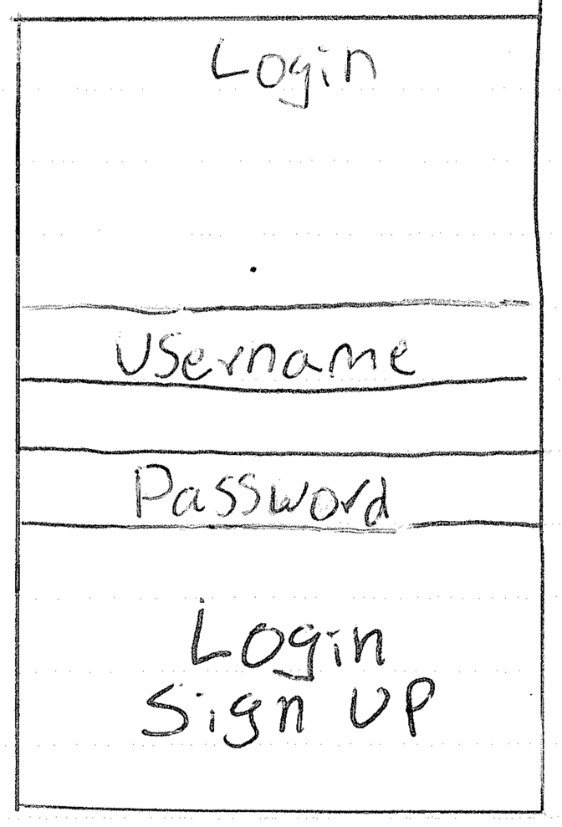

If the users choose to register an account, they will be prompted to provide information with the following registration page. The users enter their first name, last name, e-mail address and password as well as stating whether they are an RSGC parent or student, which will shape the rest of the registration process.

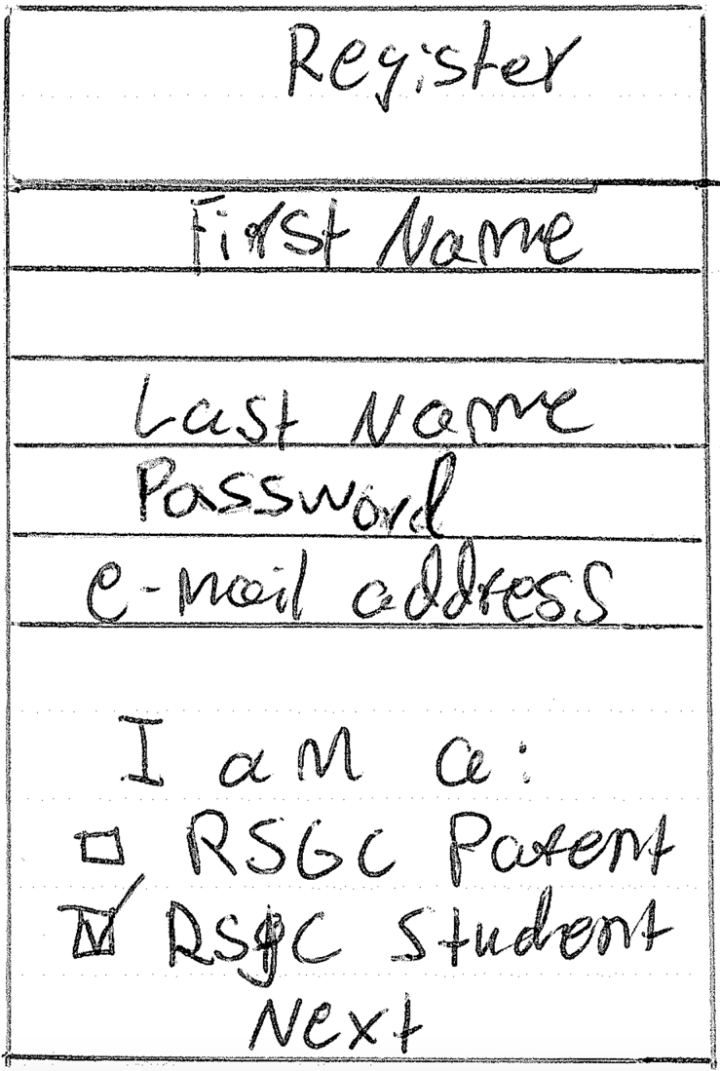

After entering this base information, and assuming the user has stated that he is an RSGC student, the user will manually enter his schedule as follows:

|  |  |
| --- | --- |
|  |  |
|  |  |

If the user states that he/she is an RSGC parent, the user will be directed to a page where he/she can add his/her son’s schedule by entering the e-mail address associated with the son’s account. A parent may also add multiple students showing up in a list on the bottom half of the screen:

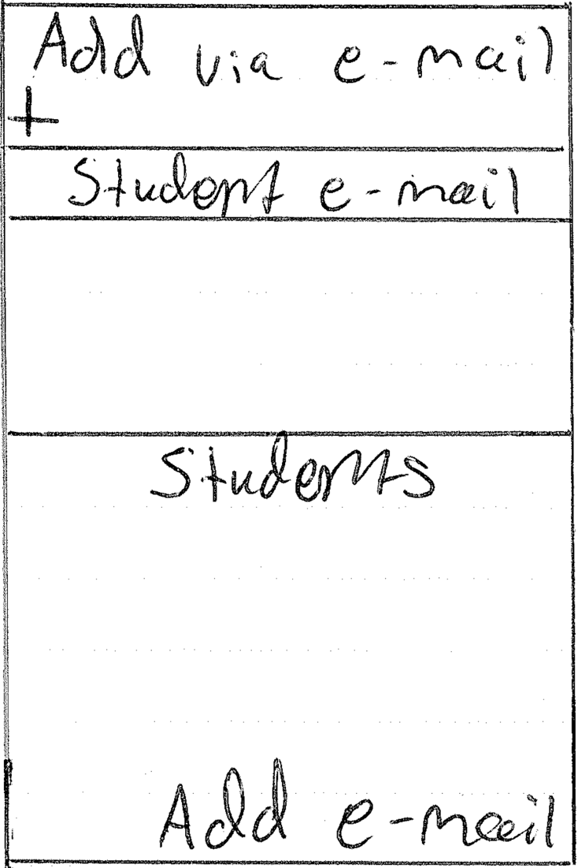

Once the user has logged in or completed the registration process, the user will be directed to the schedule page. The schedule page will include several types of information and functionalities as the core of the application. The options on this screen will depend on whether read-only database access is established or not. In the case that read-only access is allowed, the percent grades will be displayed next to each class. A button with an icon shaped as a person will be available if the user is registered as a parent, allowing the parent to flip between the various schedules of each son. A cross-shaped button (indicating a plus sign) will be used to add additional students if the user is registered as a parent. A gear-shaped button will direct the user to the application’s settings menu. Additionally, there will be a “change date” button allowing the user to view the schedule on future dates.

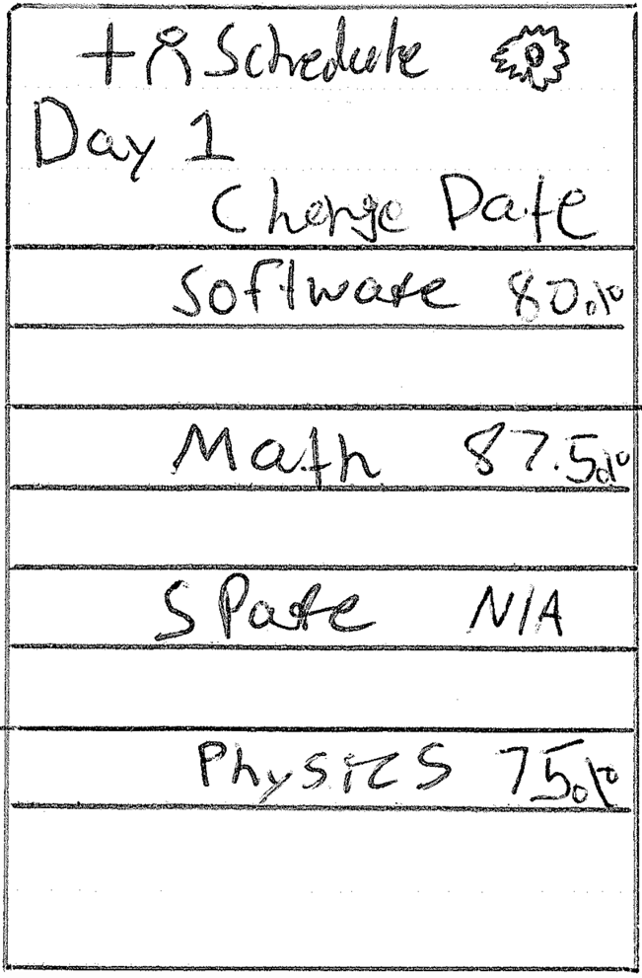

The settings menu will include four functions, for the purposes of changing the schedule, resetting the password, saving login and changing account information. These functions will only be available if the undersigned creates a custom account solution in circumstances where read-only database access is not permitted.

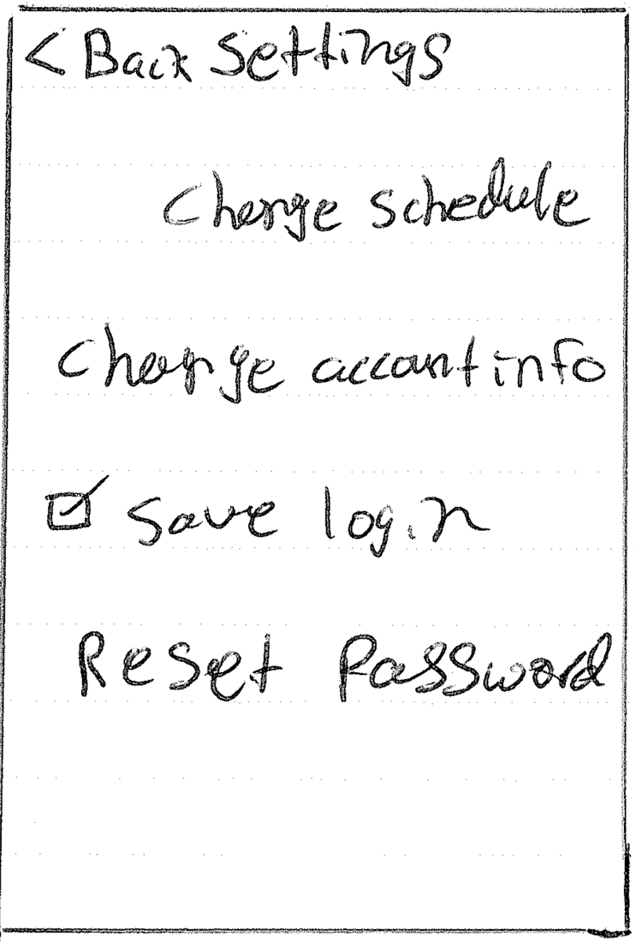

Overall, I believe this application is a very ambitious undertaking and it is likely that it will vary from this initial plan. However, this plan gives me the outline I need to approach this challenging task as efficiently as possible.